Worksheet 9.4

Killer-bot
Student: Class:
Nanotechnicians are working towards producing tiny robots capable of killing harmful bacteria, viruses and fungi that might be lurking in your body. These nanobots would be small enough to zoom through your bloodstream on their quest to eradicate the invading microbes. A team of these nanobots could devour an infection in hours, or even minutes!

Consider this . . .
What do you think a germ-fighting nanobot would look like?

What gadgets and mechanisms would it be fitted with?

How big would it be?

What types of invaders would it attack?

How would it distinguish good microbes from nasty ones?

How would the nanobot get into your body?

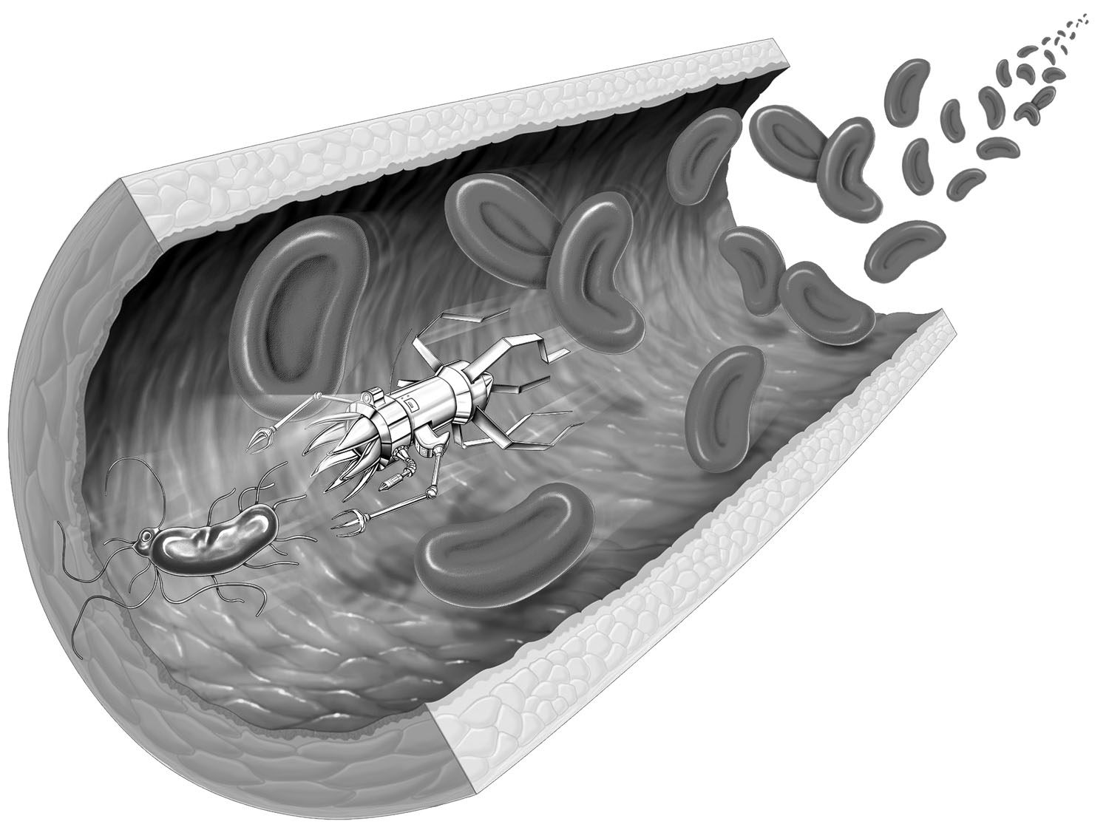
- An artist’s impression of a nanobot. Others can be found by searching the internet.
How would it get out of your body?

Who would benefit from the work of a nanobot?

Can you think of any other questions that could be asked about a nanobot? List the questions and then try to answer them.

Imagine this . . .
You have just designed the world’s first germ-fighting nanobot, only you can’t start production of the tiny lifesavers without the backing of some sponsors. Your job now is to convince a group of businesspeople to financially back your nanobot project.

Create this . . .
Create a PowerPoint presentation aimed at the businesspeople whose sponsorship you desperately require. The presentation should include facts about your nanobot and the reasons why the sponsors should fund your project. Refer to your answers to the ‘Consider this’ questions.

Present this . . .
Present your sponsorship plea to your class (who will act as the businesspeople). At the end of your presentation, the businesspeople can ask any relevant questions they may have. After all the presentations have been heard and considered, the class must discuss the presentations and then agree on one (or more) nanobot projects that should be funded.

Image: Andrea Danti / Shutterstock.com

